**Experiment 2**

Name: Kaushal Banthia

Roll Number: 19CS10039

Course Name: Introduction to Electronic Laboratory Course Number: (EC29003)

**Aim:** Familiarisation and studies on RC, CR, RL and LR circuits, as passive filters and pulse responses.

**Theory:**

1. Low Pass RC Filter: In this filter, we connect a capacitor (Capacitance = C) and a resistor (Resistance = R) in series with an AC Source (Angular frequency = w) and then we measure the output voltage across the capacitor. Since the voltage is measure across the capacitor, the naming is done as RC, with C being after R.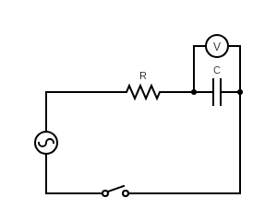

The ratio of the output voltage to input voltage comes out after doing the derivation.

$V_{in}=I*Z$ ( $I$ is the current in the circuit and $Z$ is the impedance of the circuit)

$$I=\frac{V_{in}}{Z}$$

$I=\frac{V_{in}}{R+XX_{c}}$ ($XX_{c}$ is the reactance of the capacitor)

Thus,

$$V_{out }=I*X_{c}$$

$$V_{out}=\frac{V_{in}}{R+X_{c}}*X_{c}$$

$$\frac{V_{out}}{V_{in}}=\frac{X_{c}}{R+X_{c}}$$

$\frac{V_{out}}{V_{in}}=\left(\frac{\frac{1}{jwc}}{R+\frac{1}{jwc}}\right)$ ($X_{c}=\frac{1}{jwc}$)

$$\frac{V_{out}}{V_{in}}=\left(\frac{1}{jRwc+1}\right)$$

For low values of w, we can see that the ratio is close to 1, and for extremely large values of w, the value tends towards 0. Thus, we can see that this filter allows low values of frequency and thus is called a low pass filter.

The magnitude in decibels is

$$Magnitude = 20*\log_{10}\left(|\frac{V_{out}}{V_{in}}|\right)$$

$$Magnitude = 20*\log_{10}\left(|\frac{1}{jRwc+1}|\right)$$

Its cut off frequency $(f_{3db}) = \frac{1}{2πRc}$

1. High Pass CR Filter: In this filter, we have the same connection as that in the Low Pass RC Filter, but this time, the output voltage is measured across the Resistor, instead of the capacitor. Since the voltage is measured across the resistor, the naming is done as CR, with R being after C.

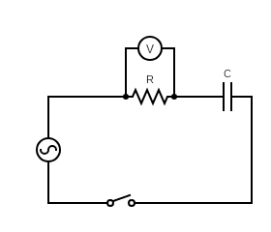

The ratio of output voltage to input voltage comes out after doing the derivation.

$V_{in}=I*Z$ ( $I$ is the current in the circuit and $Z$ is the impedance of the circuit)

$$I=\frac{V_{in}}{Z}$$

$I=\frac{V_{in}}{R+X_{c}}$ ($X_{c}$ is the reactance of the capacitor)

Thus,

$$V_{out }=I*R$$

$$V_{out}=\frac{V_{in}}{R+X_{c}}*R$$

$$\frac{V_{out}}{V_{in}}=\frac{R}{R+X_{c}}$$

$\frac{V_{out}}{V_{in}}=\frac{R}{R+\frac{1}{jwc}}$ ($X_{c}=\frac{1}{jwc}$)

$$\frac{V_{out}}{V_{in}}=\frac{jRwc}{jRwc+1}$$

For low values of w, we can see that the ratio is close to 0, and for extremely large values of w, the value tends towards 1. Thus, we can see that this filter allows high values of frequency and thus is called a high pass filter.

The magnitude in decibels is

$$Magnitude = 20*\log_{10}\left(|\frac{V_{out}}{V_{in}}|\right)$$

$$Magnitude = 20*\log_{10}\left(|\frac{jRwc}{jRwc+1}|\right)$$

Its cut off frequency $(f_{3db}) = \frac{1}{2πRc}$

1. Low Pass LR Filter: In this filter, we connect an inductor (Inductance = L) and a resistor (Resistance = R) in series with an AC Source (Angular frequency = w) and then we measure the output voltage across the Resistor. Since the voltage is measure across the Resistor, the naming is done as LR, with R being after L.

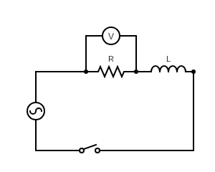

The ratio of the output voltage to input voltage comes out after doing the derivation.

$V_{in}=I*Z$ ( $I$ is the current in the circuit and is the impedance of the circuit)

$$I=\frac{V_{in}}{Z}$$

$I=\frac{V_{in}}{R+X_{L}}$ ($X_{L}$ is the reactance of the Inductor)

Thus, $V_{out }=I*R$

$$V_{out}=\frac{V_{in}}{R+X_{L}}*R$$

$$\frac{V_{out}}{V_{in}}=\frac{R}{R+X_{L}}$$

$\frac{V_{out}}{V_{in}}=\left(\frac{R}{R+jwL}\right)$ ($X_{L}=jwL$)

For low values of w, we can see that the ratio is close to 1, and for extremely large values of w, the value tends towards 0. Thus, we can see that this filter allows low values of frequency and thus is called a low pass filter.

The magnitude in decibels is

$$Magnitude = 20*\log_{10}\left(|\frac{V_{out}}{V_{in}}|\right)$$

$$Magnitude = 20*\log_{10}\left(|\frac{R}{R+jwL}|\right)$$

Its cut off frequency $(f_{3db}) = \frac{R}{2πL}$

1. High Pass RL Filter: In this filter, we have the same connection as that in the Low Pass LR Filter, but this time, the output voltage is measured across the Inductor, instead of the Resistor. Since the voltage is measured across the Inductor, the naming is done as RL, with L being after R.

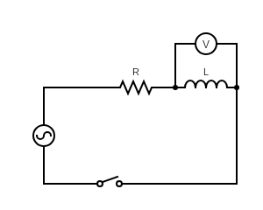

The ratio of the output voltage to input voltage comes out after doing the derivation.

$V_{in}=I*Z$ ( $I$ is the current in the circuit and is the impedance of the circuit)

$$I=\frac{V_{in}}{Z}$$

$I=\frac{V_{in}}{R+X_{L}}$ ($X_{L}$ is the reactance of the Inductor)

Thus, $V_{out }=I*X_{L}$

$$V_{out}=\frac{V_{in}}{R+X_{L}}*X_{L}$$

$$\frac{V_{out}}{V_{in}}=\frac{X_{L}}{R+X_{L}}$$

$\frac{V_{out}}{V_{in}}=\left(\frac{jwL}{R+jwL}\right)$ ($X_{L}=jwL$)

For low values of w, we can see that the ratio is close to 0, and for extremely large values of w, the value tends towards 1. Thus, we can see that this filter allows high values of frequency and thus is called a high pass filter.

The magnitude in decibels is

$$Magnitude = 20*\log_{10}\left(|\frac{V_{out}}{V_{in}}|\right)$$

$$Magnitude = 20*\log_{10}\left(|\frac{jwL}{R+jwL}|\right)$$

Its cut off frequency $(f_{3db}) = \frac{R}{2πL}$

Cut-Off Frequency: It is that frequency, at which, the output power gets halved with respect to the input power. We consider the value 50%, because after that the signal strength becomes too weak due to attenuation and thus the signal becomes irrelevant. It is coined the term $f_{3db}$, because, when the power gets halved, it is said to decrease by approximately 3 decibels. (Since $10*\log_{10}(\frac{P_{out}}{P_{in}})$ $≈ -3$ when $\frac{P_{out}}{P_{in}}=$ $\frac{1}{2}$). It can be found easily, since $P α V^{2}$. Thus, we simply equate $\frac{V_{out}}{V_{in}}=$ $\frac{1}{\sqrt{2}}$ and then replace the ratio $\frac{V_{out}}{V_{in}}$ by its corresponding formula for the respective filter, as we have found above.

**Procedure:**

The experiments are done in Virtual Labs Simulator and Falstad.

For each filter, a circuit is made from Falstad and then it is simulated to get the values of the Magnitude in decibels, by using the formula $Magnitude = 20*\log_{10}\left(|\frac{V_{out}}{V_{in}}|\right)$

These values can be assumed to be the observation values

Then using the formula for magnitude that we earlier derived, we can draw the graph for each of the filters. These values are the theoretical values

Low Pass RC Filter: For R = 10000 Ω, c = 46.91 nF and Vinput = 5 V, $\left(f_{3db}\right)= 339.28 Hz$

|  |  |  |  |  |
| --- | --- | --- | --- | --- |
| Frequency  (f) in Hz | Vin  in V | Vout  in V | Magnitude (Theoretical) = $$20*\log_{10}\left(\frac{V_{out}}{V_{in}}\right)$$ in decibels (dB) | Magnitude (Observational) =  in decibels (dB) |
| 50 | 5 | 4.946 | -0.094 | -0.093 |
| 149 | 5 | 4.575 | -0.772 | -0.766 |
| 438 | 5 | 3.062 | -4.259 | -4.260 |
| 1294 | 5 | 1.268 | -11.917 | -11.916 |
| 3818 | 5 | 0.442 | -21.071 | -21.060 |
| 11627 | 5 | 0.149 | -30.516 | -30.702 |
| 25000 | 5 | 0.064 | -37.856 | -37.349 |

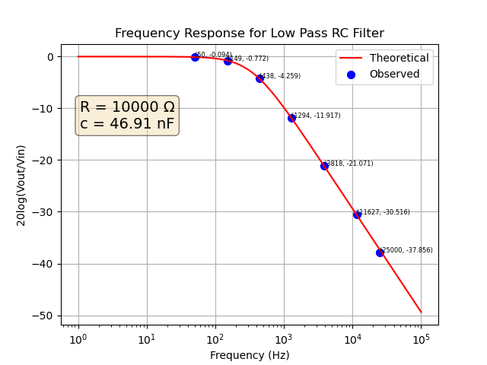

Graph Made Using the Matplotlib library in Python

1. High Pass CR Filter: For R = 10000 Ω, c = 46.91 nF and Vinput = 5 V, $\left(f_{3db}\right)= 339.28 Hz$

|  |  |  |  |  |
| --- | --- | --- | --- | --- |
| Frequency  (f) in Hz | Vin  in V | Vout  in V | Magnitude (Theoretical) = $$20*\log_{10}\left(\frac{V_{out}}{V_{in}}\right)$$ in decibels (dB) | Magnitude (Observational) =  in decibels (dB) |
| 50 | 5 | 0.729 | -16.725 | -16.725 |
| 149 | 5 | 2.011 | -7.911 | -7.913 |
| 438 | 5 | 3.953 | -2.041 | -2.041 |
| 1294 | 5 | 4.837 | -0.288 | -0.289 |
| 3818 | 5 | 4.98 | -0.035 | -0.034 |
| 11627 | 5 | 4.998 | -0.003 | -0.004 |
| 25000 | 5 | 4.999 | -0.002 | -0.001 |

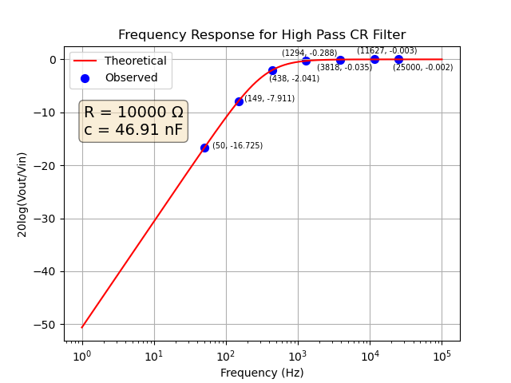

Graph Made Using the Matplotlib library in Python

1. Low Pass LR Filter: For R = 10000 Ω, L = 1 H and Vinput = 5 V, $\left(f_{3db}\right)= 1591.55 Hz$

|  |  |  |  |  |
| --- | --- | --- | --- | --- |
| Frequency  (f) in Hz | Vin  in V | Vout  in V | Magnitude (Theoretical) = $$20*\log_{10}\left(\frac{V_{out}}{V_{in}}\right)$$ in decibels (dB) | Magnitude (Observational) =  in decibels (dB) |
| 50 | 5 | 4.998 | -0.003 | -0.004 |
| 149 | 5 | 4.978 | -0.038 | -0.038 |
| 438 | 5 | 4.821 | -0.317 | -0.317 |
| 1294 | 5 | 3.879 | -2.205 | -2.204 |
| 3818 | 5 | 1.922 | -8.304 | -8.296 |
| 11627 | 5 | 0.671 | -17.445 | -17.354 |
| 25000 | 5 | 0.301 | -24.408 | -23.940 |

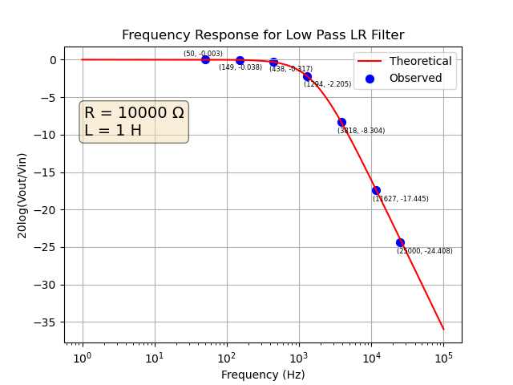

Graph Made Using the Matplotlib library in Python

1. High Pass RL Filter: For R = 10000 Ω, L = 1 H and Vinput = 5 V, $\left(f_{3db}\right)= 1591.55 Hz$

|  |  |  |  |  |
| --- | --- | --- | --- | --- |
| Frequency  (f) in Hz | Vin  in V | Vout  in V | Magnitude (Theoretical) = $$20*\log_{10}\left(\frac{V_{out}}{V_{in}}\right)$$ in decibels (dB) | Magnitude (Observational) =  in decibels (dB) |
| 50 | 5 | 0.157 | -30.061 | -30.061 |
| 149 | 5 | 0.466 | -20.612 | -20.611 |
| 438 | 5 | 1.327 | -11.522 | -11.524 |
| 1294 | 5 | 3.154 | -4.002 | -4.002 |
| 3818 | 5 | 4.616 | -0.694 | -0.696 |
| 11627 | 5 | 4.955 | -0.079 | -0.081 |
| 25000 | 5 | 4.989 | -0.019 | -0.017 |

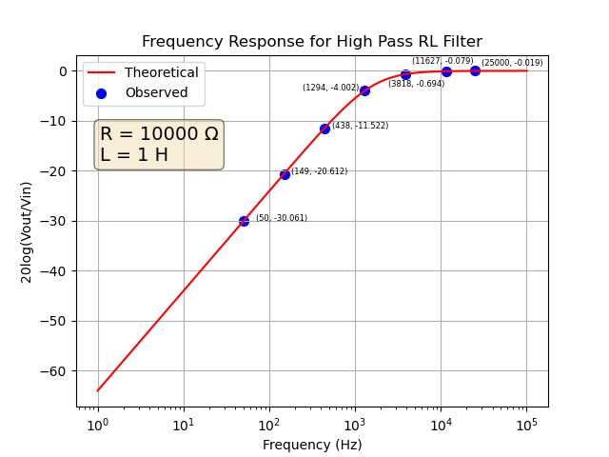

Graph Made Using the Matplotlib library in Python

**Conclusion:** From the above experiments, now we can distinguish between different passive filters, namely, the Low Pass RC, the High Pass CR, the Low Pass LR, and the High Pass RL and also understand their characteristics.

**Theory (Pulse Responses):**

Integrator: When a square wave source is input, and the following conditions are met, the output is a triangular wave. Such a circuit is also called as an Integrator, since the output voltage is proportional to the integration of the input.

Conditions:

1. The circuit is a **low pass RC** Filter
2. The resistance is at least 10 times **greater** than the Reactance
3. The time constant of the circuit is **much greater** than the time period of the wave.

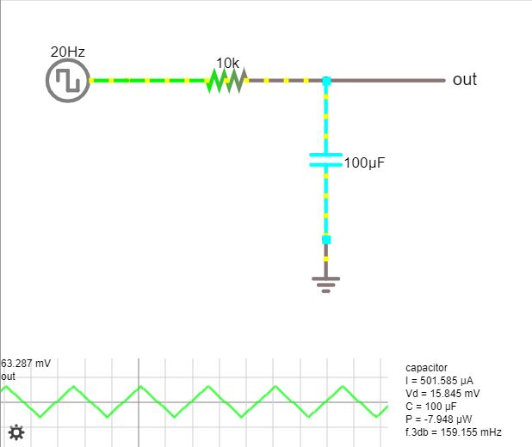

Due to these conditions, we can do the following calculations.

$V_{source}=V_{R}$ (Since R >> X)

Also, since the Time constant of the circuit is too large as compared to the time period of the signal, a triangular wave shape with a low amplitude will be produced as the capacitor has less time to fully charge or discharge. Now,

$${V_{source}=V}_{R}=IR$$

$$I=\frac{V_{source}}{R}$$

Also,

$$Q=\int{I}dt$$

Output Voltage $V_{out}=\frac{Q}{c}$

$$V_{out}=\frac{\int{I}dt}{c}$$

$V_{out}=\frac{\int{V_{source}}dt}{Rc}$

This proves that the output voltage is proportional to the integral of the source voltage if the above conditions are met.

Differentiator: When a square wave source is input, and the following conditions are met, the output are unit impulses. Such a circuit is also called as a Differentiator, since the output voltage is proportional to the derivative of the input.

Conditions:

1. The circuit is a **high pass CR** Filter
2. The resistance is at least 10 times **lesser** than the Reactance
3. The time constant of the circuit is **smaller** than the time period of the wave.

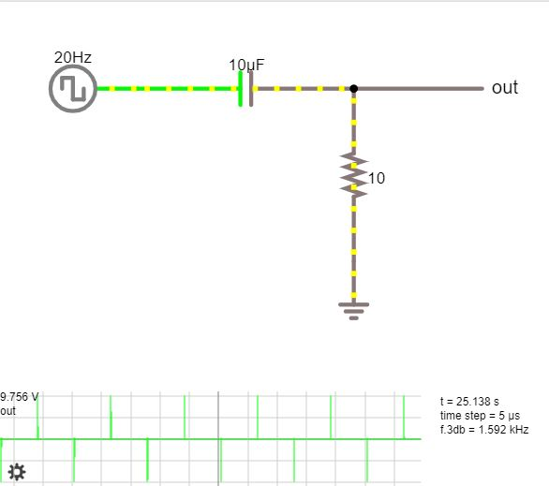

Due to these conditions, we can do the following calculations.

$V_{source}=V_{c}$ (Since X >> R)

Also, since the Time constant of the circuit is too small as compared as compared to the time period of the signal, this means that gets charged and discharged very quickly and thus we get the sharp edges. Now,

$$Q_{c}=cV_{c}$$

Also,

$$I= \frac{dQ_{c}}{dt}$$

$$I= c\frac{dV_{c}}{dt}$$

Output Voltage $V_{out}=IR$

$$V_{out}= c\frac{dV_{c}}{dt}*R$$

$$V_{out}= Rc\frac{dV_{c}}{dt}$$

This proves that the output voltage is proportional to the derivative of the source voltage if the above conditions are met.